Reddit

Client_ID (PK)

Client_Secret

User_Agent

Username

Password

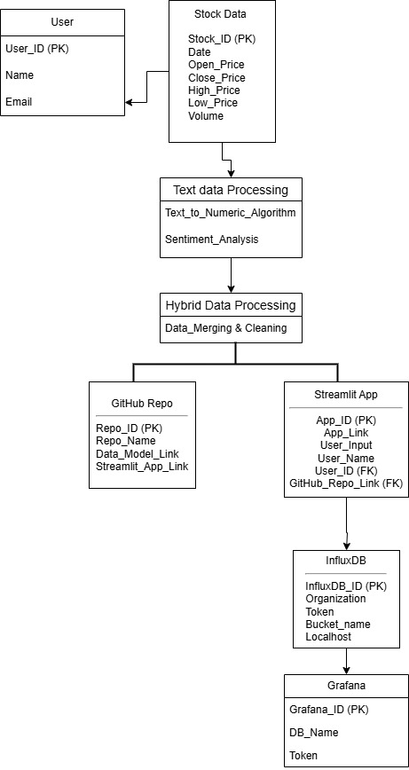





PowerBI

App_ID (PK)

Stock_ID (FK)

